Activity No. 1.1
Flowcharting and Application of Pseudo codes
Course Code: CPE010 | Program: Computer Engineering
Course Title: Data Structures and Algorithms | Date Performed: 8/29/26
Section: CPE11S1 | Date Submitted: 8/29/26
Name(s): Paula Esguerra | Instructor: Engr. Jimlord Quejado
6. Output

Assignment 1.1: Flowcharting and Application of Pseudo codes
- Provide a flowchart design for the following ATM functions:
- Changing pin
- Withdraw
- Deposit
- Fund Transfer
- Provide also pseudocodes for the aforementioned functions.
- Post your answers here. This discussion will be graded, thus, everyone is encouraged to submit their solutions.

Changing Pin

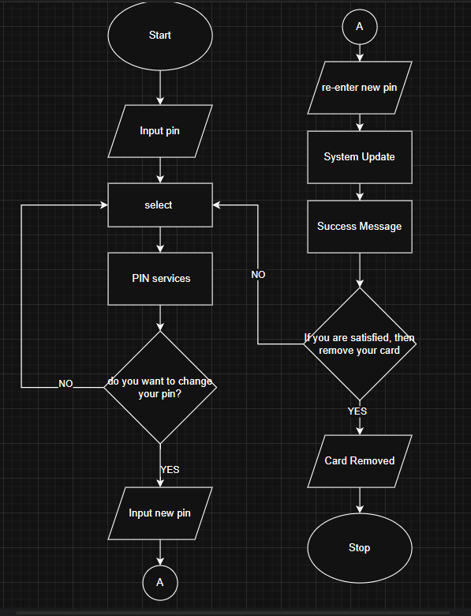
Start
Input pin
Select
Select Pin Services
Do you want to change your pin?
If no, then go back to select
If yes, input new pin
Re-enter new pin
System Update
Success Message
If you are satisfied, then remove your card
If no, then go back to select
If yes, Card Removed
Stop

Withdraw

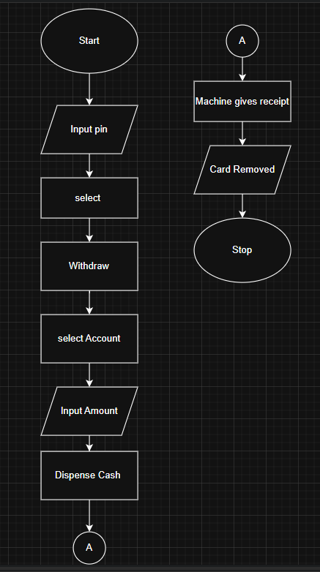
Start
Input pin
Select
Select Withdraw
Select Account
Input Amount
Dispense Cash
Machine gives receipt
Card Removed
Stop

Deposit

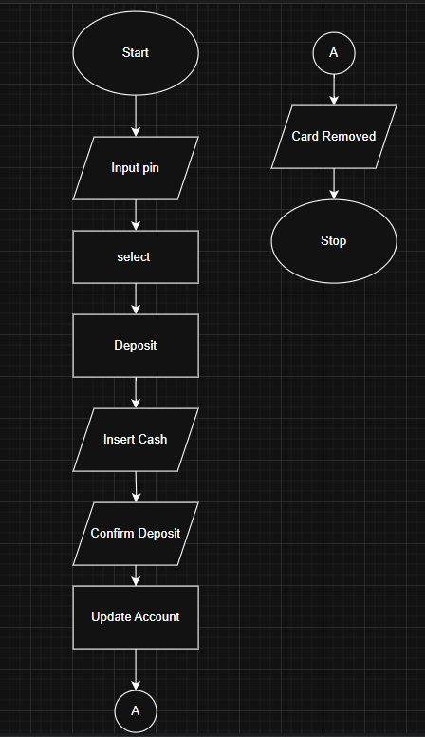
Start
Input pin
Select
Select Deposit
Insert Cash
Confirm Deposit
Update Account
Card Removed
Stop

Fund Transfer

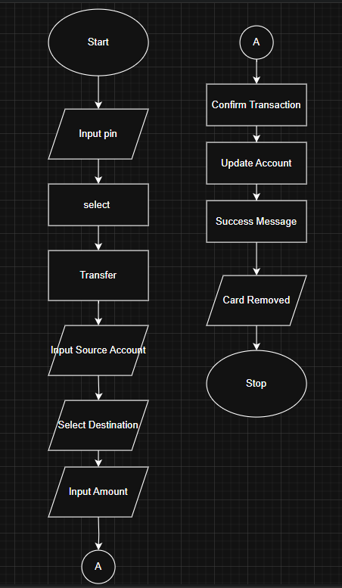
Start
Input pin
Select
Select Transfer
Input Source Account
Select Destination
Input Amount
Confirm Transaction
Update Account
Success Message
Card Removed
Stop
7. Supplementary Activity
8. Conclusion
After all the exercises and activities done before, this assignment is much easier to do, learning if/else is much faster to work on, the loop, and how to use the input properly. This is really useful, to understand what are you going to do, to think what comes next, how to shorten the process so it wouldn’t be redundant. And lastly, some things doesn’t change, first you put what are you going to input first, then the process, and it’s output, but it would be longer if you want to use the decision, give its yes and no decisions.
9. Assessment Rubric

